****C LANGUAGE

INTRODUCTION OF C LANGUAGE

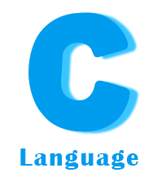

TOPICS :-

1.History of c language

2.Importance of c language

3.Program devoplement steps

4.structure of c language

HISTORY OF C LANGUAGE

* 1960 ALGOL International group
* 1967 BCPL Martin Richards

* 1970 B Ken Thompson
* 1972 TRADITIONAL C Dennis Ritchie
* 1978 K&RC Kernighan and Ritchie
* 1983 ANSIC ANSI committee
* 1990 ANSIC & ISO ISO committee
* 1999 C99 Standradization committee